GAS POWER TRAINING

Houston Learning Center (HLC)
8800 Wallisville Road | Houston, Texas 77029 | USA
Welcome!
This center provides Aeroderivative, Excitation, Controls, Boiler, Craft, Gas and Steam Turbine training, and is located on a 15-acre lot, with dedicated training areas to each of the product lines. Enclosed is information about our facility such as site policies, safety, hotel recommendations and general information. Whether visiting for training or general business meetings, we hope you enjoy your visit, and we look forward to working with you. Please travel safely and let us know if we can be of any assistance.

Travel Security
GE Vernova uses the following two applications to help inform you of travel security.
Please download and install these applications prior to your travels.
  GardaWorld Travel Security |  |  |   Crisis Messenger
  APPLE iOS |   ANDROID OS |  | APPLE iOS | ANDROID OS

Arriving at the Houston Facility
All visitors must check in at the main lobby, front desk and show proof of identification to obtain a visitors’ badge which must be worn at all times.
Instructions will be given as to where to park and in which building your course is held.

Dress Code
The required dress is “business casual”. No shorts, sandals, tank tops, or shirts with inappropriate verbiage or signs are permitted. Jeans are acceptable that are clean and free of holes.

Personal Protective Equipment (PPE)
GE Vernova students attending any “maintenance” training course are asked to bring their GE Vernova PPE clothing, hard hats, safety glasses (Z87 standard) and safety-toed shoes. Appropriate PPE clothing, hard hats, safety glasses and safety-toed shoes are required when performing shop maintenance tasks. Failure to have proper PPE requirements may result in student not being able to participate in affected portions of the course.

Hands-on Facility Equipment
Only qualified and authorized personnel are allowed to operate cranes and forklifts.

Open Enrollment Course - Training Hours
Training courses are conducted in English and all training material will be in English.
Course schedule time: 8:00 a.m. to 4:00 p.m.

No Smoking Policy
There is a strict smoking ban on-site (including e-cigarettes). Smoking is restricted to designated smoking areas which must be always kept clean.

Videotaping and Photography
Due to the technical nature of these classes, and the current legal environment, photography or recording of GE classes using audio or video is strictly prohibited.

EHS
The facility adheres to EHS policies and procedures. A full time EHS representative is present during working hours. Any questions or concerns regarding EHS should be directed to your lead instructor or escalated as appropriate.

Amenities
Cafeteria onsite serving breakfast and lunch.
Prayer rooms and mother’s room are available for your convenience.

General Recommendations
Keep a copy of your passport, driving license, and health insurance in your luggage in case of loss.

Visitors
No visitors are allowed in our training bays or site property unless authorized. All requests for permission for non-employees to enter the site should be made to security in the Building 1 lobby. Visitors who enter the facility shall be escorted by a HLC employee.
Employees are requested to challenge strangers in the facility who do not have the necessary approval for access to our facility. Unauthorized visitors should be escorted courteously but quickly to security in the Building 1 lobby.

Family Members
Site visitations of family members of any employee at the facility must be limited to approved visitations only. To have an approved visitation, a request must be submitted to the employee’s manager, and the family member visiting must be escorted by an employee while not in a vehicle.
Children on site with an approved visitation shall be always in the company of the employee and under adult supervision. Children are limited to personal vehicles, offices, and office lobby areas only (non-shop areas). Under no circumstances will children be permitted into the active training areas.

Entertainment
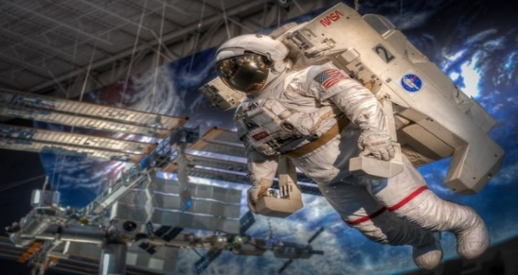 | - Downtown Aquarium/Restaurant/Amusement Park  - Museum District – History, Science and Health  - Space Center Houston  - Galleria Shopping Mall – high end department stores, skating and dining (approximately 30-minute drive)

Area Hotels
We recommend staying in the northeast Houston area, Galleria, downtown or near the IAH airport, within the guidelines of the T&L policy.
We further recommend against the properties mentioned below, as there have been recent thefts from the parking lot.
Candlewood Suites  I-10 East (Extended Stay Hotel)  1020 Maxey Road | Holiday Inn Express and Suites  11460 East Freeway I-10 East  Houston, TX 77029 USA

Houston Site Layout Information




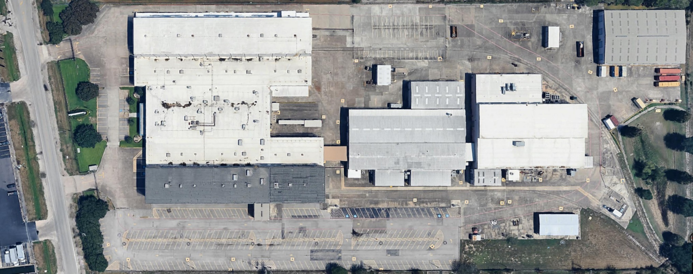
Building
2
Building
3
Building
1
Main Entrance
Building 1
If the evacuation alarm sounds, leave the building immediately and assemble to the nearest muster point located on the map.
In case of emergency dial 911.

 | Emergency Assembly Point
 | Student Parking Area
 | Permitted Smoking Area
 | Site/Facility Entrance
 | Site/Facility Exit

Directions from George Bush Intercontinental Airport (IAH)
George Bush Intercontinental Airport (IAH)
2800 N Terminal Road, Houston, Texas 77032
(Approximately 20 miles – 25 min. without traffic)
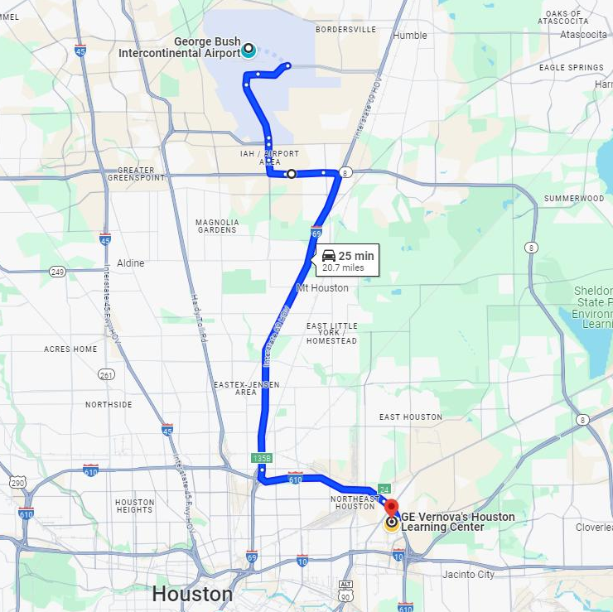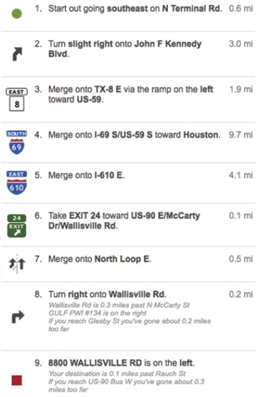

Directions from William P. Hobby Airport (HOU)
William P. Hobby Airport (HOU)
7800 Airport Blvd, Houston, Texas 77061
(Approximately 11 miles – 20 min. without traffic)
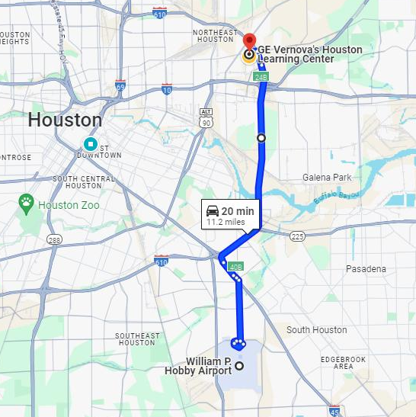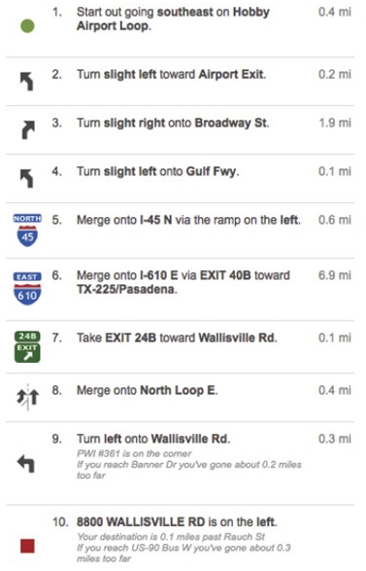

General EHS practices in any urban city
As you prepare for your time at the Houston Learning Center (HLC), we wanted to provide you with some important safety tips to ensure your stay in Houston is enjoyable and secure.
When selecting a hotel, we recommend choosing establishments that are well-known and have good reviews from previous guests. It's also a good idea to consider hotels that are in safe and well-lit areas, preferably in popular tourist districts.
Remember to always lock your hotel room and utilize any provided safety features, such as electronic key cards or room safes, to keep your belongings secure.
Own Car / Rental Car
If you plan to rent a car during your stay or bring your own car, be mindful of the following safety precautions:
- Consider using an RFID key fob protection sleeve (sleeve preventing anyone from copying your car-key signal and stealing then the car with this copy). www.wikihow.com/Protect-Keyless-Car-Fobs
- Always lock your car doors and keep valuables out of sight to deter theft.
- Always bring your belongings (backpack or purse) with you. Do not leave it in the car or in the trunk.
- When parking, opt for well-lit and secure areas, especially at night. Park near or next to a CCTV or parking lot cameras, if possible.
- Be cautious when stopping at gas stations and try to choose well-populated ones.
- Keep an eye on your surroundings and be aware of any suspicious individuals or activities.
- Notify immediately your GE Vernova contact, instructor, Resource Manager or People Leader, and EHS for any vehicle event(s).
Weather conditions
- Watch out for potentially severe weather conditions such as heavy rain, storm, hurricanes, tornados, fires, and freezing events as there is a high risk of flooding, power loss and other, similar impact associated to it. We recommend downloading a local weather App, such as weather bug or Red Cross emergency app for early warning and alert notifications.
In case such situation occurs while in Houston
- If at the hotel when situation occurs: Stay at the hotel in case of any potential flooding risk, power loss or other severe weather condition. Stay calm and connect with your GE Vernova Training contact or wait till you receive a message from GE Vernova Training org. Please do not try to travel to the HLC or any other destination until you are explicitly advised to do so.
- If at the Houston Learning Center when situation occurs: stay calm and follow advise given by GE Vernova Training staff.
- If it unexpectedly occurs during your stay in the city or when travelling: stay calm, identify the closest safe place to stay (hotel, shopping mall, restaurant, Hospital/medical care place, etc) and follow advise given by local authorities

IMPORTANT:
Ensure you have your mobile phone with you, participant mobile numbers known to the GE Vernova Training team will receive messages with advice on how to proceed.
General Precaution: Never drive into standing water, it may be deeper than it looks!



